Jobsheet Laporan Pembuatan Sisfo PKL

Nama:Andra Fakhrezi

Kelas:XII RPL 3

Mapel:MK

Tanggal:23-7-2025

Guru:Annisah Husni Daulay,M.Kom

Tujuan:

1.Memahami ilmu coding

2.Terbiasa membuat html dan css

Alat Dan Bahan:

1.Perangkat Keras (Hardware):

1. PC Sekolah

2.Perangkat Lunak (Software)

1. Visual Studio Code
2. Website Color Hunt

Teori Singkat

Sistem Informasi adalah suatu sistem yang dirancang untuk mengumpulkan, menyimpan, mengelola, dan menyebarkan informasi guna mendukung pengambilan keputusan, koordinasi, analisis, dan pengawasan dalam sebuah organisasi

Desain Interface

1.Halaman Home

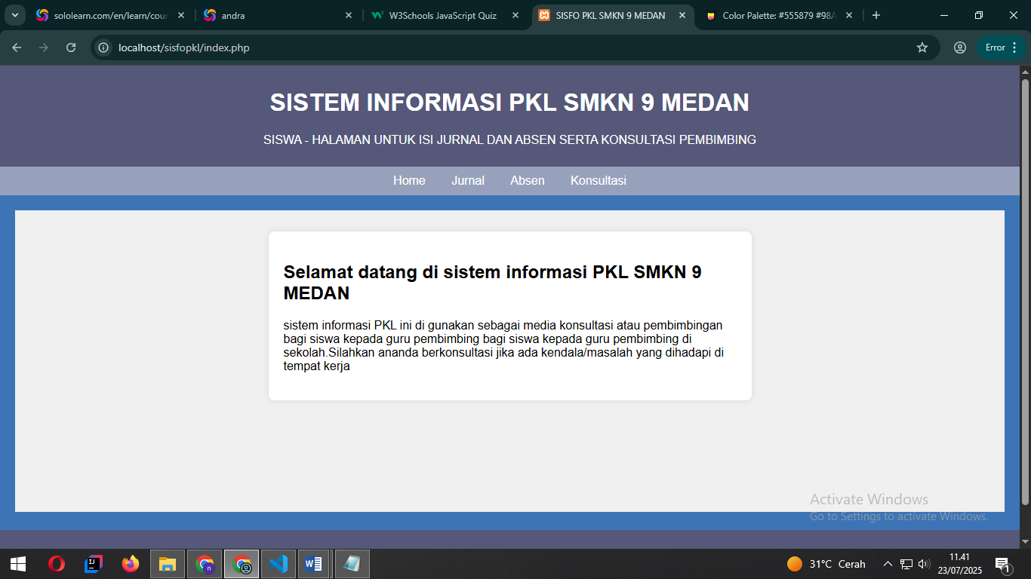

2.Halaman Jurnal

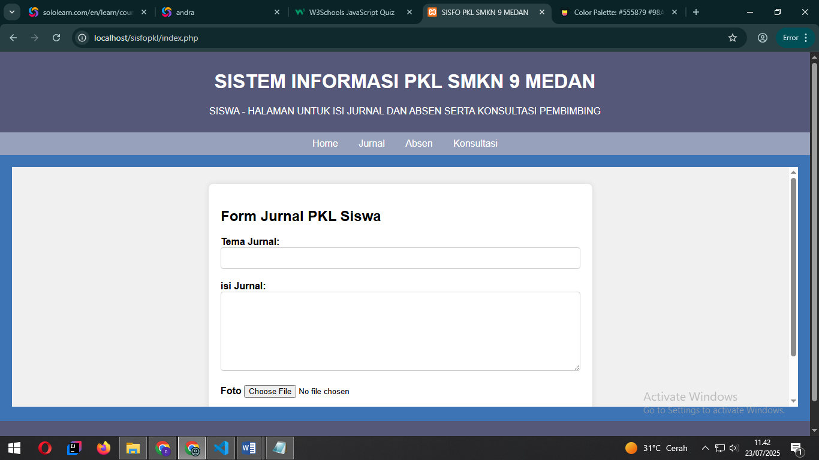

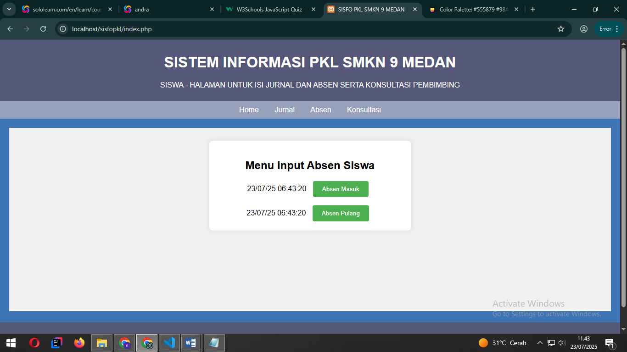

3.Halaman Absen

4.Halaman Konsultasi

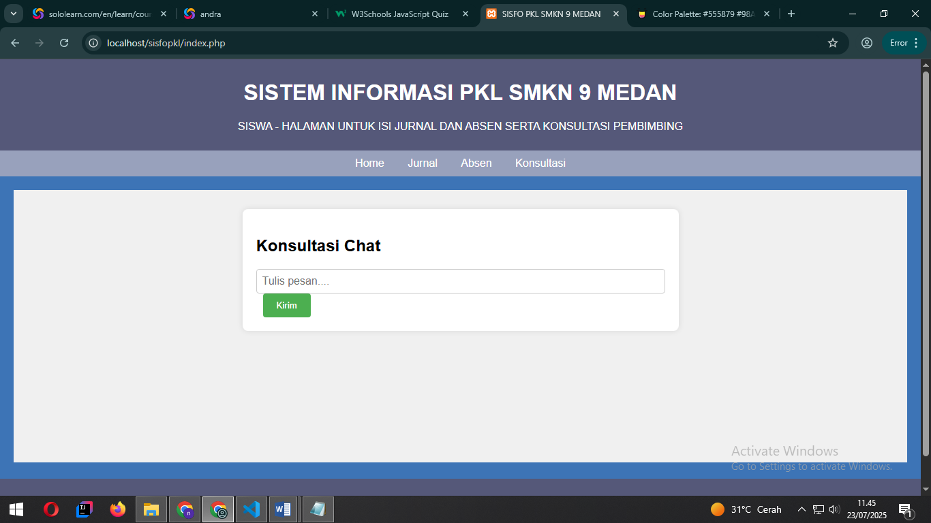

Langkah-Langkah

1.Buka Visual Studio Code.

2.Buat folder baru bernama Sisfo PKL

3.Didalam folder Sisfo PKL buat file Bernama

A.Index.php

<!DOCTYPE html>

<html lang="en">

<head>

    <meta charset="UTF-8">

    <meta name="viewport" content="width=device-width, initial-scale=1.0">

    <title>SISFO PKL SMKN 9 MEDAN</title>

    <style>

        body{

            font-family:Arial, sans-serif;

            margin:0;

            padding: 0;

            background-color:#3D74B6;

        }

        header, footer{

            background-color:#555879;

            color:white;

            text-align:center;

            padding:10px 0;

        }

        nav{

            background-color:#98A1BC;

            padding:10px;

            text-align:center;

        }

        nav a{

            color:white;

            padding:0 15px;

            text-decoration:none;

        }

        nav a:hover{

            text-decoration:underline;

        }

        #content{

            padding:20px;

        }

        iframe{

            width:100%;

            height:400px;

            border:none;

        }

    </style>

</head>

<body>

    <?php include 'header.php';?>

    <?php include 'menu.php';?>

    <div id="content">

        <iframe name="contentFrame" src="crud/home.php"></iframe>

    </div>

    <?php include 'footer.php';?>

</body>

</html>

B.Menu.php

<nav>

    <a href="crud/home.php" target="contentFrame">Home</a>

    <a href="crud/jurnal.php" target="contentFrame">Jurnal</a>

    <a href="crud/absen.php" target="contentFrame">Absen</a>

    <a href="crud/konsultasi.php" target="contentFrame">Konsultasi</a>

</nav>

C.Header.php

<header>

    <h1>SISTEM INFORMASI PKL SMKN 9 MEDAN</h1>

    <p>SISWA - HALAMAN UNTUK ISI JURNAL DAN ABSEN SERTA KONSULTASI PEMBIMBING</p>

</header>

D.Footer.php

<footer>

    <p>

        SMEKDA Coding-Design By Andra

    </p>

</footer>

5.Buat folder “crud”

6.Di dalam folder crud buat file bernama

A.absen.php

<!DOCTYPE html>

<html lang="en">

<head>

    <meta charset="UTF-8">

    <meta name="viewport" content="width=device-width, initial-scale=1.0">

    <link rel="stylesheet" href="styles.css">

    <title>Document</title>

</head>

<body>

    <div class="menu">

        <h2>Menu input Absen Siswa</h2>

        <?php echo date("d/m/y H:i:s");?>

        <button onclick="inputAbsen('masuk')">Absen Masuk</button><br>

        <br>

        <?php echo date("d/m/y H:i:s");?>

        <button onclick="inputAbsen('pulang')">Absen Pulang</button>

    </div>

    <script>

        function inputAbsen(type){

            if(type === 'masuk'){

                alert('Absen masuk berhasil dicatat.');

            }else if(type === 'pulang'){

                alert('Absen pulang berhasil dicatat');

            }

        }

    </script>

</body>

</html>

B.Home.php

<!DOCTYPE html>

<html lang="en">

<head>

    <meta charset="UTF-8">

    <meta name="viewport" content="width=device-width, initial-scale=1.0">

    <title>Home</title>

    <link rel="stylesheet" href="styles.css">

</head>

<body>

    <div class="chat-container">

        <h2>Selamat datang di sistem informasi PKL SMKN 9 MEDAN</h2>

        <p>sistem informasi PKL ini di gunakan sebagai media konsultasi atau

            pembimbingan bagi siswa kepada guru pembimbing bagi siswa kepada

            guru pembimbing di sekolah.Silahkan ananda berkonsultasi jika ada

            kendala/masalah yang dihadapi di tempat kerja </p>

    </div>

</body>

</html>

C.Jurnal.php

<!DOCTYPE html>

<html lang="en">

<head>

    <meta charset="UTF-8">

    <meta name="viewport" content="width=device-width, initial-scale=1.0">

    <title>Halaman Jurnal</title>

<link rel="stylesheet" href="styles.css">

</head>

<body>

    <div class="container">

        <h2>Form Jurnal PKL Siswa</h2>

        <div class="form-group">

        <label for="theme">Tema Jurnal:</label>

        <input type="text" id="theme" name="theme" required>

        </div>

        <div class="form-group">

        <label for="content">isi Jurnal:</label>

        <textarea id="content" name="content" rows="6" required ></textarea>

        </div>

        <div class="form-group">

        <label for="photo">Foto</label>

        <input type="file" id="photo" name="photo" accept="image/\*">

        </div>

        <button type="submit">Submit</button>

    </div>

</body>

</html>

D.Konsultasi.php

<!DOCTYPE html>

<html lang="en">

<head>

    <meta charset="UTF-8">

    <meta name="viewport" content="width=device-width, initial-scale=1.0">

    <title>Halaman Konsultasi</title>

    <link rel="stylesheet" href="styles.css">

</head>

<body>

    <div class="chat-container">

<h2>Konsultasi Chat</h2>

<div class="chat-box" id="chatBox">

</div>

<input type="text" id="chatInput" class="chat-input"

placeholder="Tulis pesan....">

<button onclick="sendMessage()">Kirim</button>

    </div>

    <script>

function sendMessage(){

    const chatInput = document.getElementById('chatInput');

    const chatBox = document.getElementById('chatBox');

    const message = chatInput.value.trim();

    if(message){

        const userMessage = document.createElement('div');

        userMessage.className = 'message user';

        userMessage.innerText = message;

        chatBox.appendChild(userMessage);

    const adminMessage = document.createElement('div');

    adminMessage.className = 'bebas';

    adminMessage.innerText = 'Admin:Terima Kasih,pesan anda telah diterima.';

    chatBox.appendChild(adminMessage);

    chatBox.scrollTop = chatBox.scrollHeight;

    chatInput.value = '';

    }

}

    </script>

</body>

</html>

E.Styles.css

body{

    font-family: Arial, sans-serif;

    background-color: #f0f0f0;

    padding: 20px;

}

.menu{

    max-width: 400px;

    margin: 0 auto;

    background-color:#fff ;

    padding: 20px;

    border-radius: 8px;

    box-shadow: 0 0 10px rgba(0,0,0,0.1);

    text-align: center;

}

button{

    background-color: #4CAF50;

    color: white;

    padding: 10px 20px;

    border: none;

    border-radius: 4px;

    cursor: pointer;

    margin: 0 10px;

}

button:hover{

    background-color: #45a049;

}

.chat-container{

    max-width: 600px;

    margin: 0 auto;

    background-color: #fff;

    padding: 20px;

    border-radius: 8px;

    box-shadow: 0 0 10px rgba(0,0,0,0.1);

}

.container{

    max-width: 600px;

    margin: 0 auto;

    background-color: #fff;

    padding: 20px;

    border-radius: 8px;

    box-shadow: 0 0 10px rgba(0,0,0,0.1);

}

.form-group{

    margin-bottom: 20px;

}

label{

    font-weight: bold;

}

input[type="text"], textarea{

    width: 100%;

    padding: 8px;

    font-size: 16px;

    border: 1px solid #ccc;

    border-radius: 4px;

    box-sizing: border-box;

}

.button{

    background-color: #4CAF50;

    color: white;

    padding: 10px 20px;

    border: none;

    border-radius: 4px;

    cursor: pointer;

}

button:hover {

    background-color: #45a049;

}